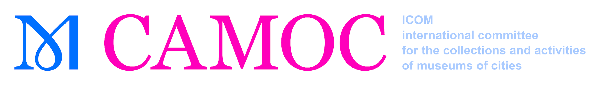
Young ICOM Members’ Travel Grant Programme 2023
APPLICATION FORM

Support for Young Members’ participation in ICOM CAMOC (International Committee for the Collections and Activities of Museums of Cities) Conference from
15 to 19 October in New York City, USA

Deadline of Application: 30 June 2023 by midnight (GTM+1)

Please return this completed form and the documents listed on page 3 to:
secretary.camoc@icom.museum (Subject: Young Members Application 2023)

Applicant Details
Surname(s)
First name(s)
Date of birth

Individual ICOM Membership number
ICOM member since
Member of CAMOC
since
Institution
Position in your Institution
Professional Address
City Postal code Country
Telephone number
E-mail

Additional Information
Are you an active member of other ICOM National or International Committees? (Please specify) | Please note that you cannot attend more than one IC meeting in 2018 by means of this travel grant.
From where will you be travelling? (Please specify airport, city and country)

Do you have any additional funding possibilities? (Please SPECIFY)

Have you benefitted from ICOM Travel Grants in previous years? | If YES, please specify the type of meeting, the venue and country, as well as the year. (for example: ICOM General Conference, Prague, 2022)
Recommendation Letter
Name of Recommending Person
E-Mail of recommending Person
Telephone number of recommending Person

I herewith declare:
- that I am 40 years or younger (as of 31 December 2023) and eligible to apply according to the Criteria for ICOM Travel Programmes.
- that I am available to FULLY attend the aforementioned ICOM International Committee Meeting.

Date | Applicant’s Signature

This application form shall not be considered if all fields are not filled in

Criteria
for the Award of Travel Grants for Participation of Young ICOM Members

All applicants should be:
- 40 years of age or under.
- individual members of ICOM and of CAMOC
- Aware that priority will be given to young CAMOC members presenting at the conference
- Aware that young members who have received grants in the last three years will not be given priority for a grant in 2023
- up-to-date with their membership dues for 2023

All applications must include:
    - the completed and signed application form
    - a 500 words statement of the applicant’s motivation for attending the annual meeting and the benefits which are expected to derive from it
    - the applicant’s curriculum vitae indicating training, work experience, publications as well as current work responsibilities within their institution (maximum one page)

Each grantee will be required to submit a report within four weeks following the meeting, stating their experience and contribution to ICOM activities and its International Committee.

Two grants of 600 euros will be given out. The amount needs to be justified with proof of payment and the sum will be transferred to the grantee after having submitted the report.

May you have any related questions please contact CAMOC at:
secretary.camoc.icom@gmail.com

